**My SQL Database :-**

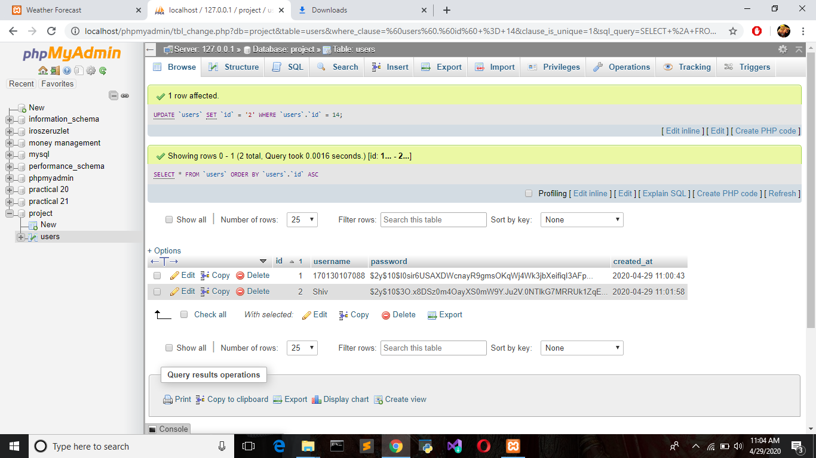

**This is the database that is connected with website named project and the table name is users.**

**The new entry of the user that we will get form signup that will be stored here and for existing user to retrieve data for log in also use this table.**

**Main Page :-**

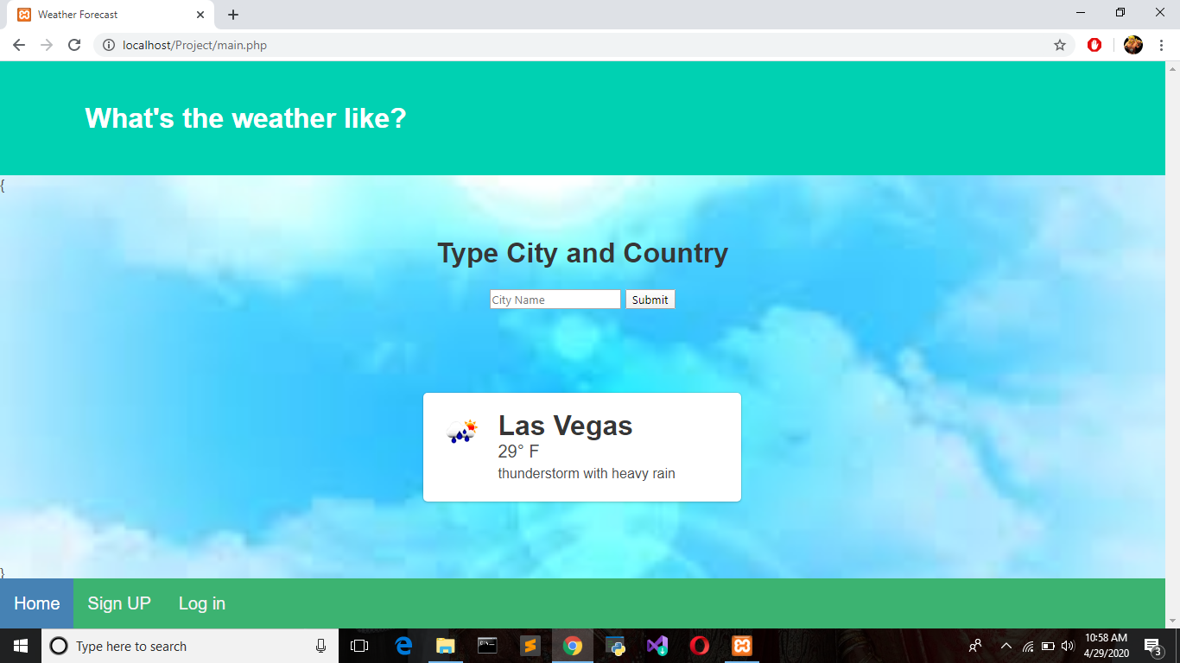

**Here is the main page of the website.**

**This this home page of the website.**

**After Entering the City name Do Press on the submit :-**

**Example (Ahmedabad) :-**

**RESULT**

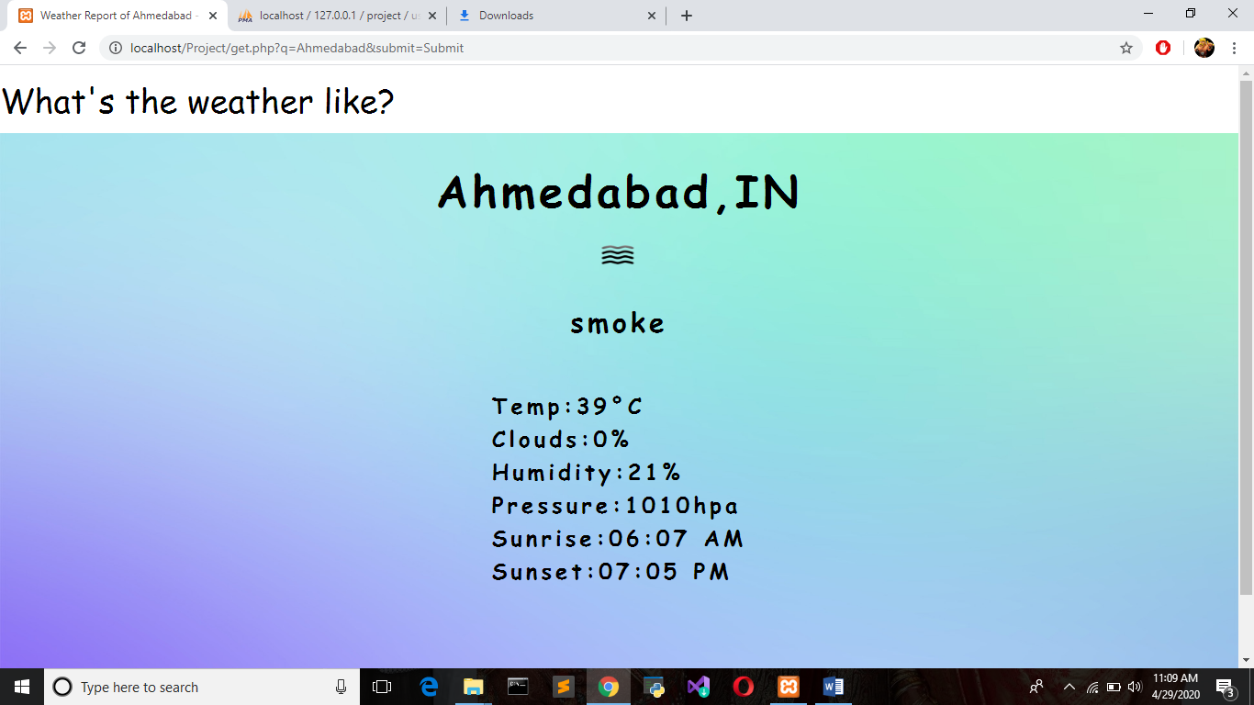

**Signup and login Page :-**

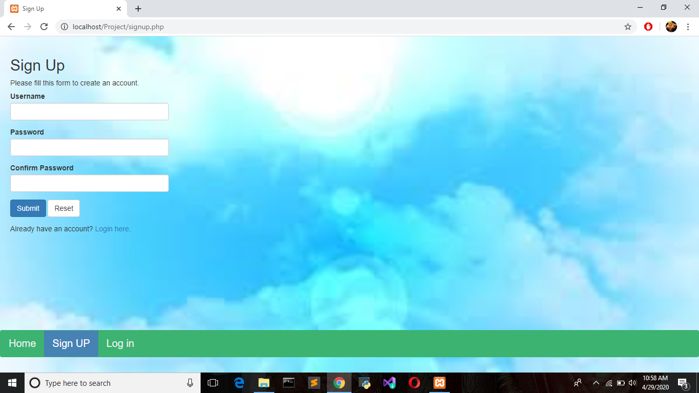

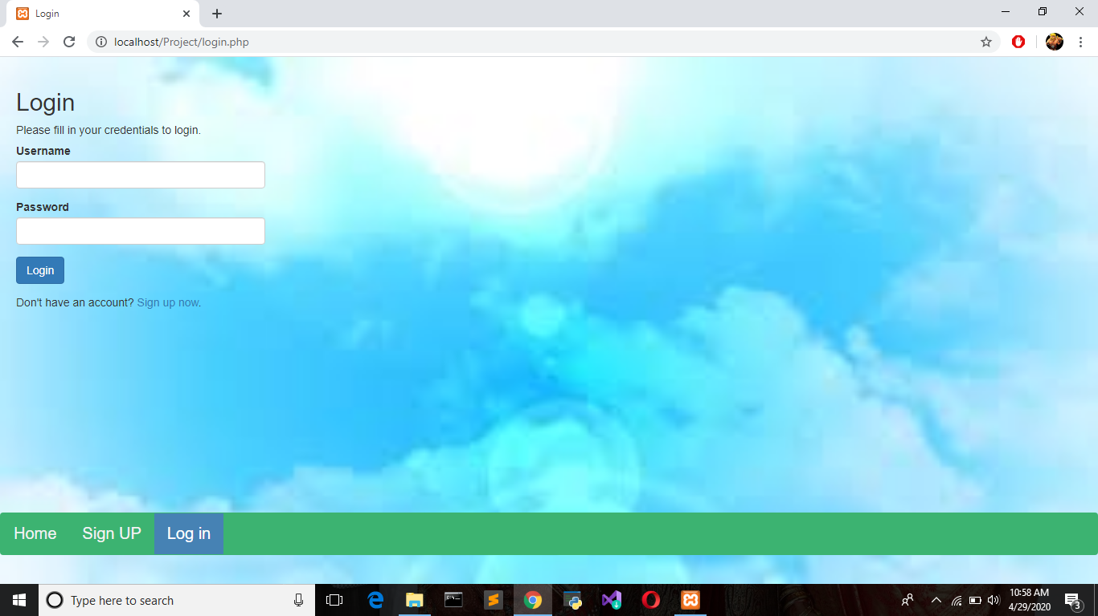

**After the login the welcome page will be displayed :-**

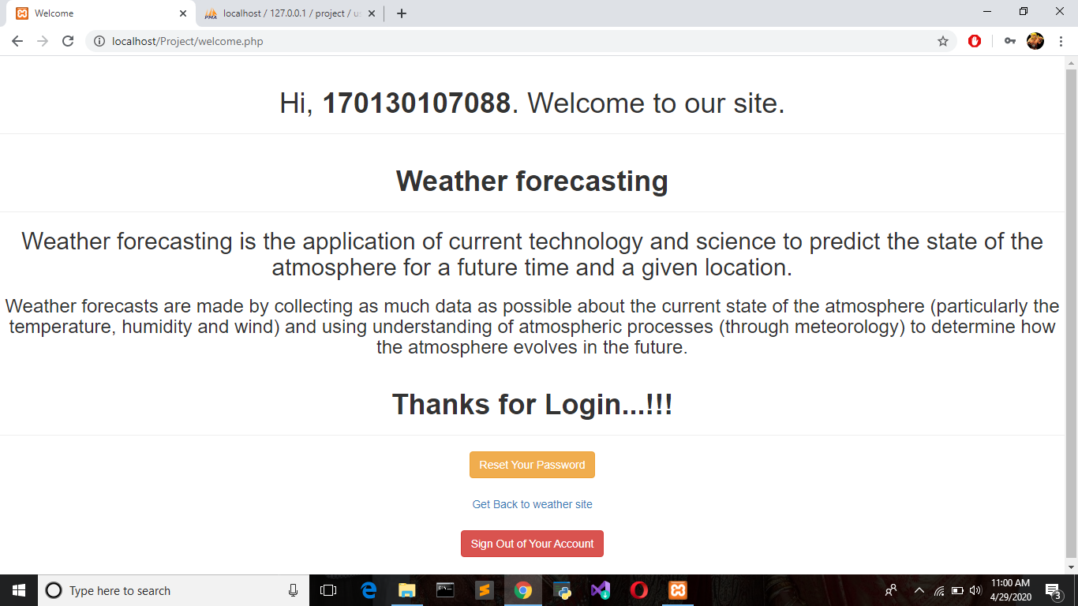

**Here the user is “170130107088”.**

**And this page welcomes the user who logged in.**